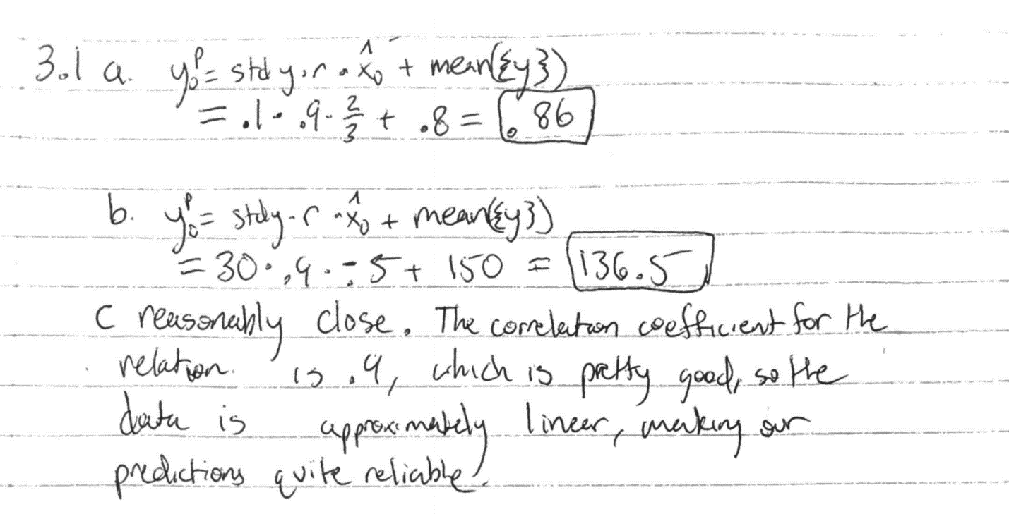

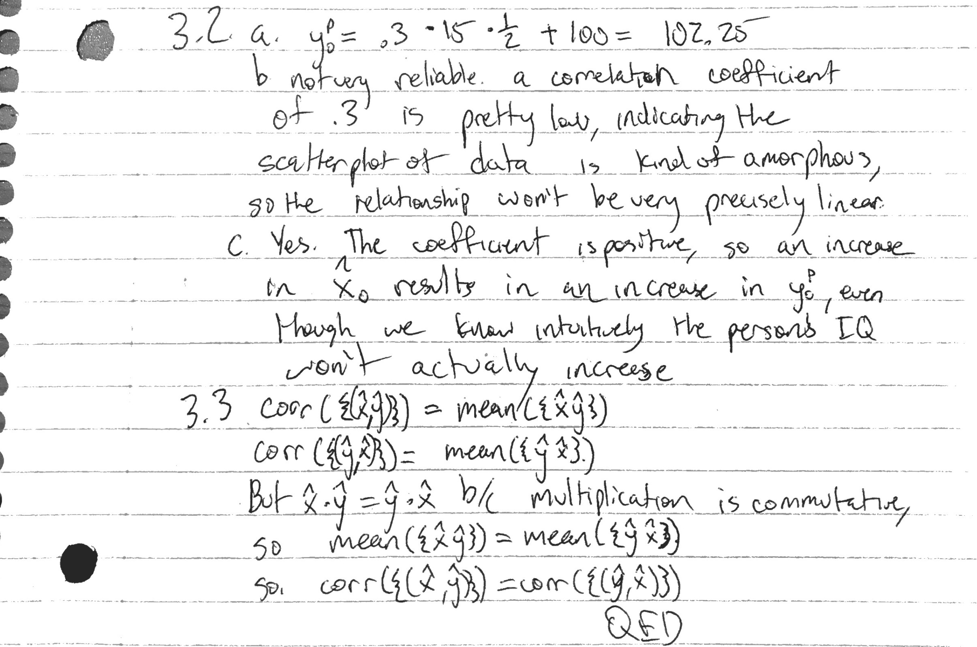

0

0

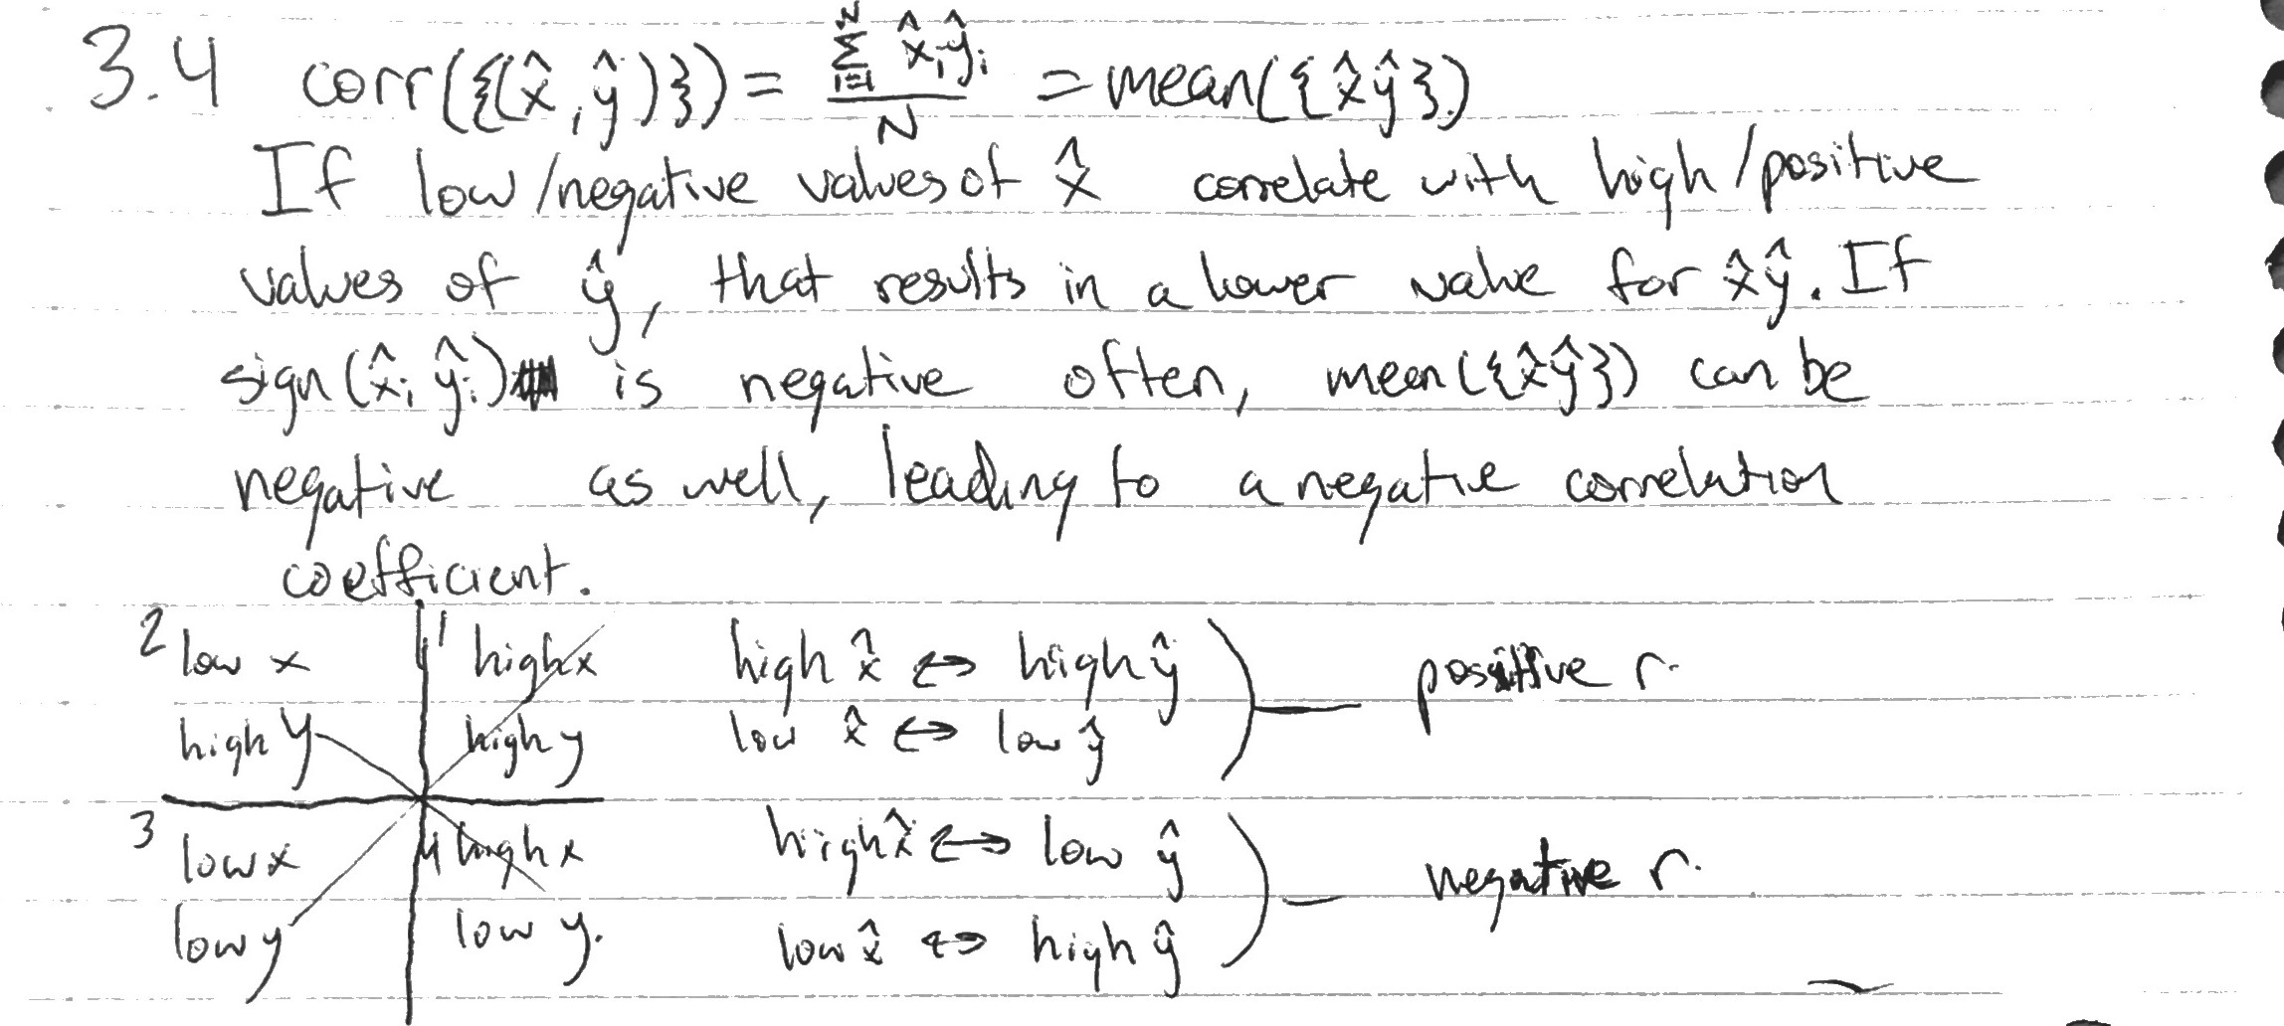

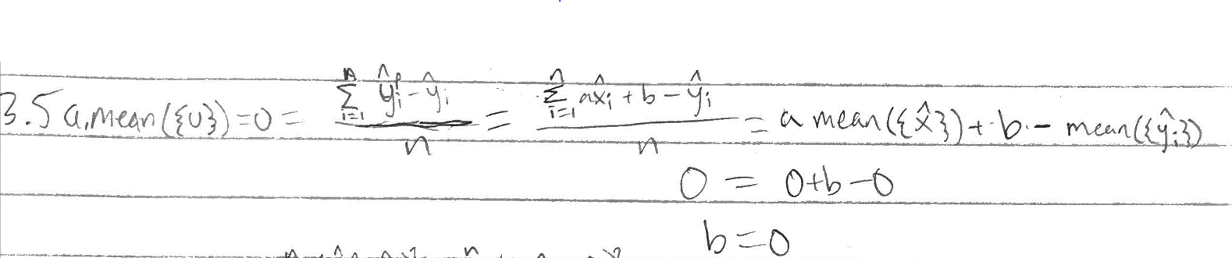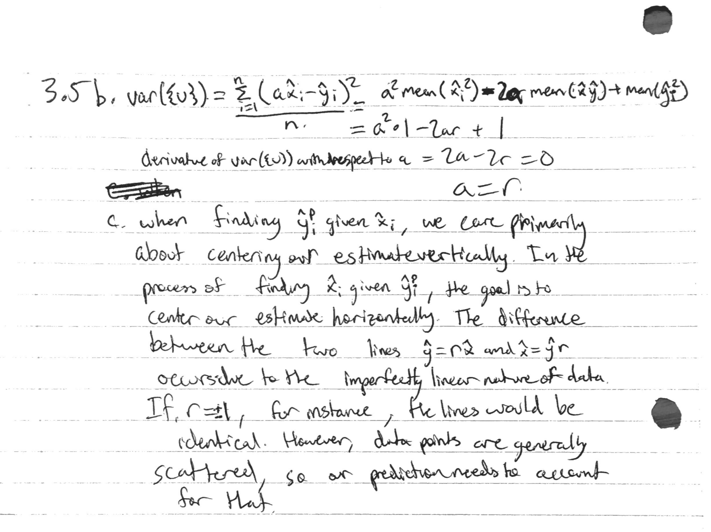

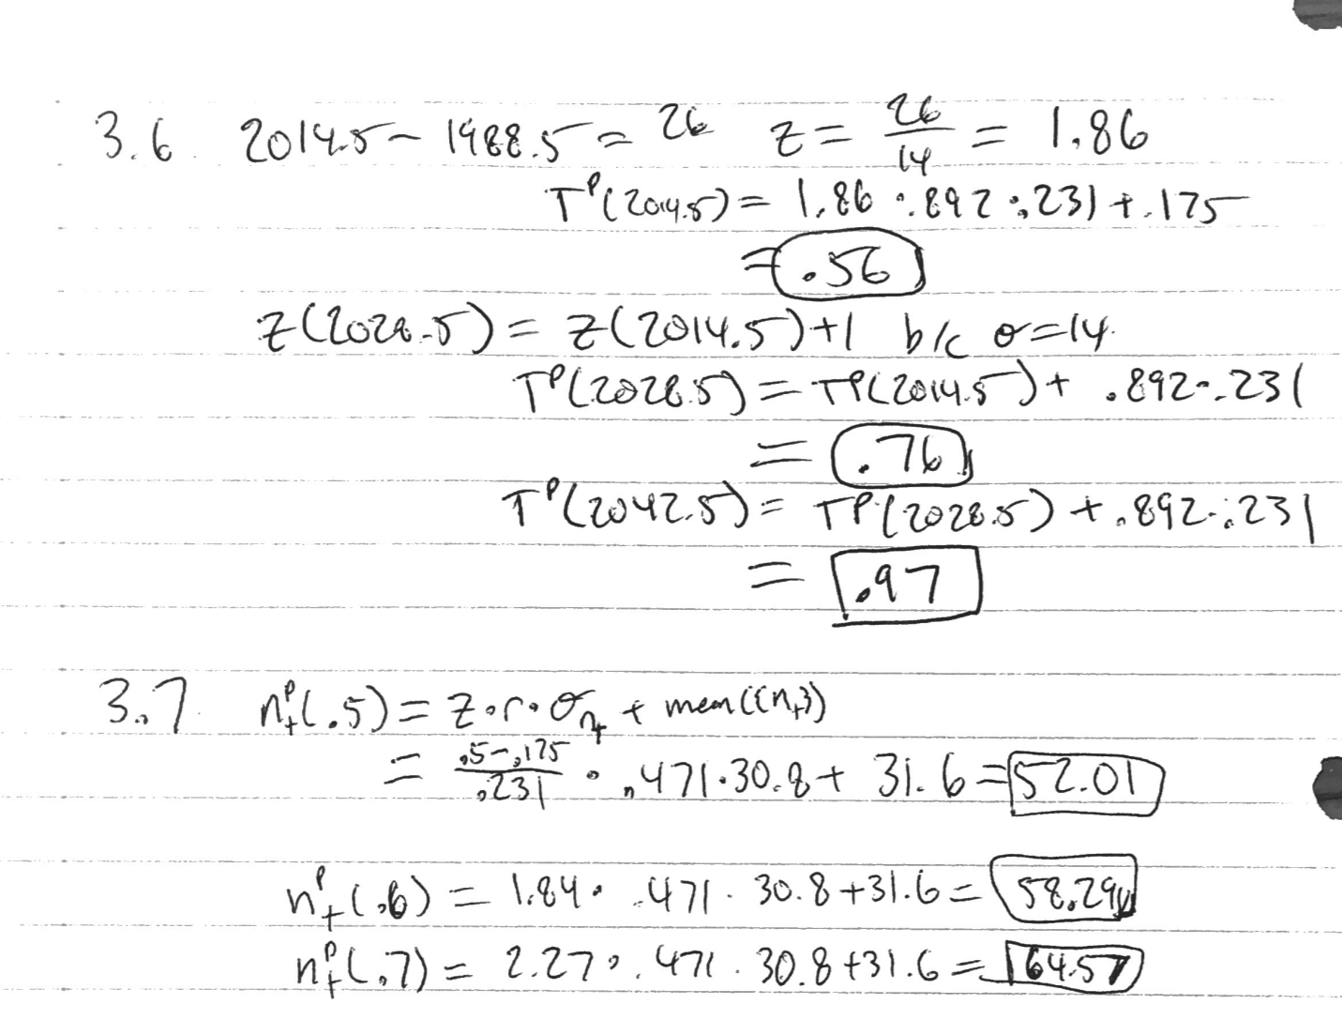

3.8.

1. 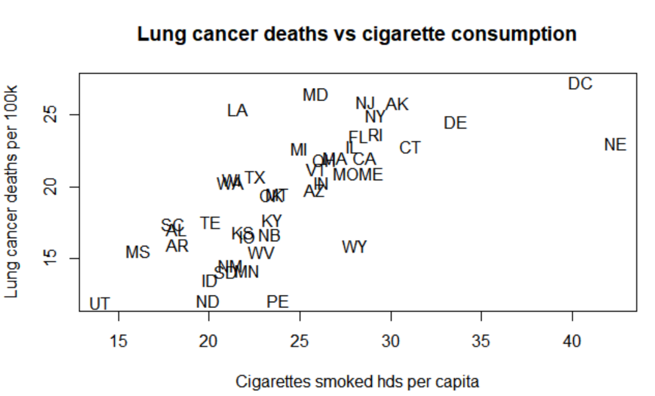
2. R with outliers = .697, r with outliers removed = .750
3. R with outliers = .703, r with outliers removed = .669
4. R with outliers = .487, r with outliers removed = .513
5. R with outliers = -.068, r with outliers removed = -.024
6. No, correlation doesn’t necessarily imply causation. It could theoretically be a reverse causation (lung cancer leads to higher chance of smoking) or there could be a latent variable (people of a certain personality type could be more likely to be addicted to smoking, and more likely to consume other substances that contribute to lung cancer).
7. No. Once again, correlation does not imply causation. It’s possible that smoking contributes to a shorter life span due to other causes, which decreases the odds of an individual eventually contracting leukemia.­­­­­­